**Functional Block Diagram**

**Current Prototype: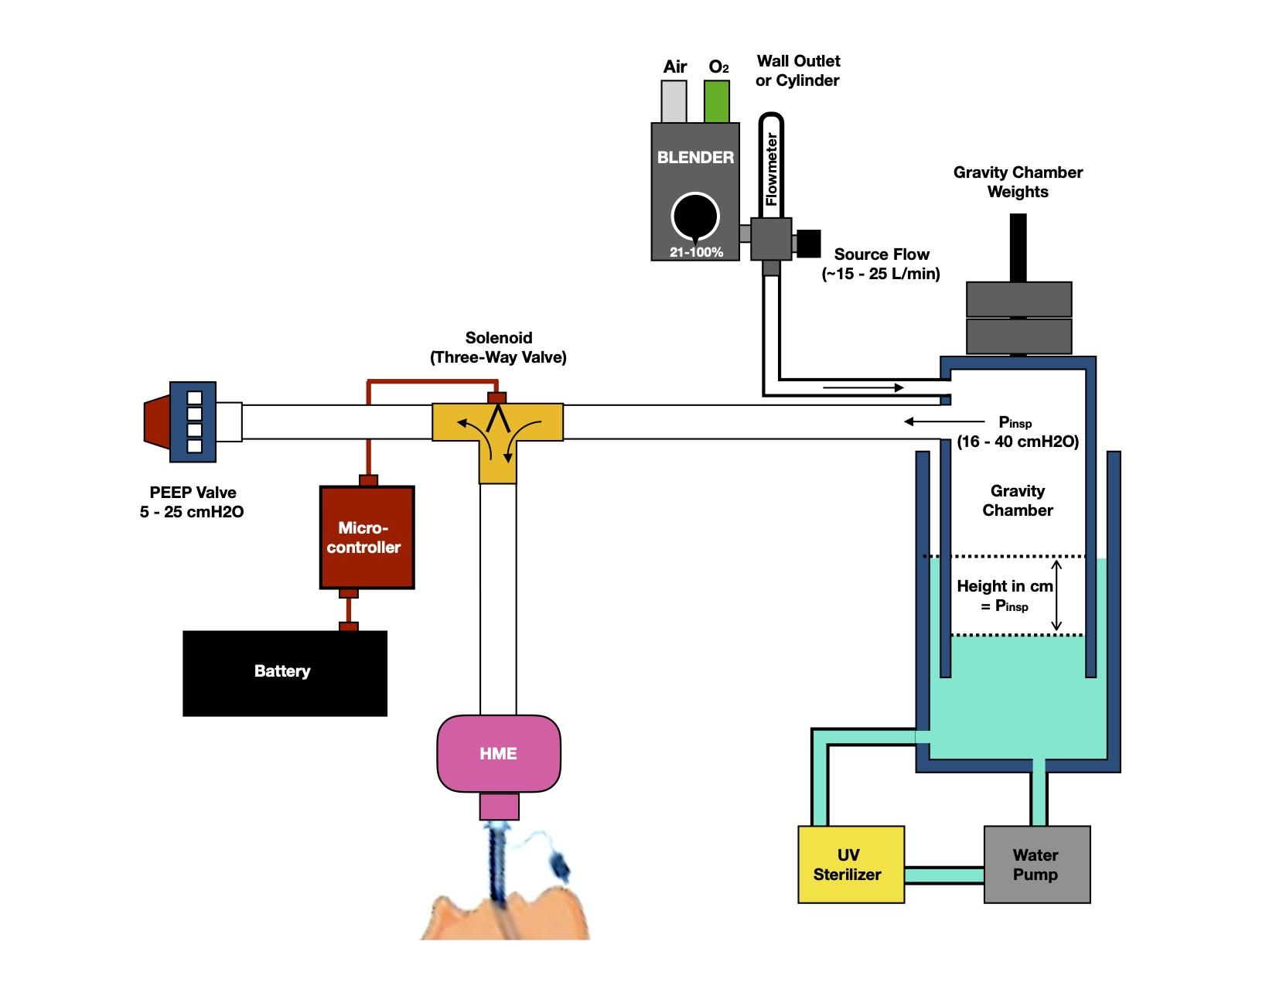**The current prototype is a mass powered pressure chamber with a water seal. This system is capable of providing a constant inspiratory pressure with a built-in pressure limit. An oxygen blender provides the range of FiO2 settings, while a flowmeter provides the flow that pressurizes the gravity chamber. A solenoid alternates between the pressure chamber and the PEEP Valve, allowing for set inspiratory and set expiratory pressures. A microcontroller with analog interface allows for modification of Respiratory Rate and I:E Ratio. An HME filters expired air, keeping components free from secretions and other gross soiling, while providing passive heat and humidification.

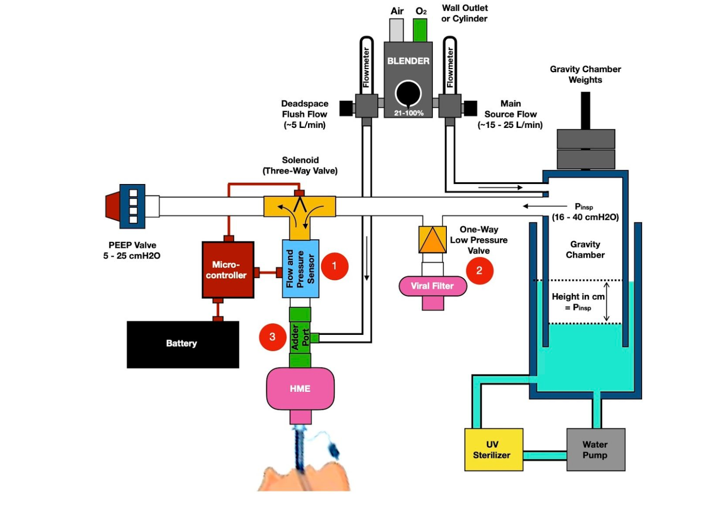

**Near Future Additions:** There are three planned essential additions that will improve the functionality and safety of this device.

1. The addition of a flow and pressure sensor will allow for pressure, volume, and flow monitoring, but also allow for sensing patient efforts. This will also allow for the inclusion of important volume and pressure alarms.
2. A one-way check valve will allow the patient to draw room air during the inspiratory phase in the event of a loss of pressure. This safety feature will prevent a possible draw of fluid from the gravity chamber into the breathing circuit. A filter ensures no contamination by air drawn from the room.
3. Given the single limb nature of the circuit, dead space will be an issue, and providing a flush flow will reduce rebreathing and also provide a flow to draw upon when triggering the ventilator.

We are awaiting delivery of parts that will allow us to incorporate these changes, and code has been written to integrate flow and pressure measurements.